Geophysical methodology, volumes and production technology, results

Magnetic exploration
Magnetic exploration is projected for geological mapping and ore zones with magnetite high grades defining. Magnetic exploration will be made at prospect areas by preliminarily done profiles, 1:10000 scale, 100x25 m grid. Distance between profiles will be 100 m. At prospect evaluation zones, the grid will be 50x25 m with thickening to 25x12.5 m. Measurements will be made by proton procession magnetometer MMP-203. Geomagnetic field’s variations account will be made by geomagnetic-variation grid (MVS) on the basis of procession magnetometer MMP-203, set at the working field. The devices are equipped by blocks for data computer filing (Fig. 4.1).

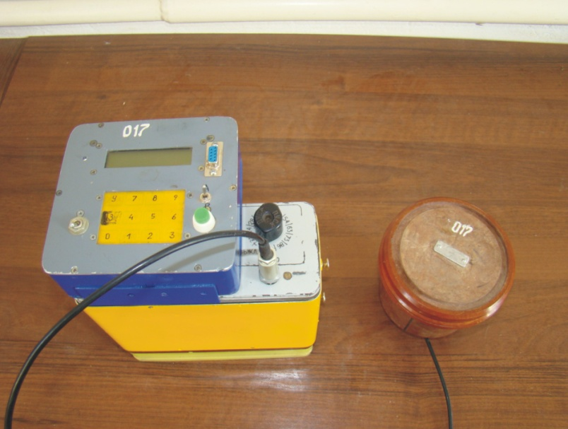
Fig. 4.1. Updated procession magnetometer MMP-203

Before surveying close to the field camp, control station and place for geomagnetic-variation system are chosen. This decision is taken on the basis of magnetic field’s gradient and sources of disturbance absence. Magnetometers comparison (regarding registration discrepancies) is made at work control profile.
Control measurements not less than 5% of common measurements are made in the field work investigation.
Control measuring accuracy with average square error (nT) is determined by formula:
$σ=±\sqrt{\frac{\sum{(X_{\text{pr}}−X_{\text{con}})^{2}}}{2n}}$,
where: X_{pr} – measured values,
X_{con} – control measurements,
n – measurements number.
Average square error should not exceed ±5 nT.
Observation results will be adjusted over variations, and amendments will be made over normal magnetic field. Later these values will be reduced to the pole using MapInfo Discover software.
Using Vertical Mapper, anomalous pole magnetic map will be compiled.

Surface gamma-spectrometry
Gamma-spectrometry is projected by preliminarily prepared profile, 100x25 m grid. At prospect evaluation areas, the grid will be 50x25m with thickening to 25x1.25 m. These works will be made by spectrometer RS-125 (Canada, RSI) (Fig.4.2), which measures K, U, Th concentrations with possible overall radioactivity measurement. Measured data are directly filed in computer and analyzed by original software up to maps compiling.
E.Ya. Ostrovsky (1974) defined, that Earth’s natural gamma-field has indicating properties, steady connected with ore and ore-perspective zones.

Fig. 4.2. Spectrometer RS-125

Radioactive gamma-field indicating properties are determined by tendency to radioactive elements (RAE) redistribution within ore-perspective zones. Along with it, there are high concentrated radioactive zones with specific redistribution and thorium and potassium antagonism, or uranium accumulation.
For this thorium or potassium redistribution definition, E.Ya. Ostrovsky derived potassium dominant formula:
$$D=(И_{k}−И_{\text{Th}})×e^{\frac{(1−x)}{2}}$$
where: И_{k} and И_{Th} – potassium and thorium grades, adjusted by average rate and standard deviation at surveyed area;
x – the lowest standard value;
e^{(1-x)/2} - empirical coefficient, counting dominance reducing with antagonistic element rising in anomalous radiation and dominance rising with its element share reducing. Dominant value is measured in arbitrary units.

We have derived our own empirical coefficient, which allows to reduce potassium dominants anomalies and possibly exclude so-called “rock” anomalies.
Devices work control is to be done every day, in the morning and in the evening, at control station.
Control measurements are made in the field survey.
Control measurements accuracy by average square error (%) is determined by formula:
$$σ=±\sqrt{\frac{\sum{(X_{\text{pr}}−X_{\text{con}})^{2}}}{2n}}$$
where: X_{pr} – measured values,
X_{con} – control measurements,
n – measurements number.
Control measurements volume is not less than 5% of total volume. The whole processing includes the usage of original software. Geological and geophysical analyses were made using MapInfo software.
As the result, RAE and potassium dominant maps will be compiled.

Dipole-dipole induced polarization
Dipole-dipole IP survey is made for geological section exploration at the 400 m depth. Works methodology is as follows: with current dipole AB one grounding, receiver dipole MN is subjected to measurements, which gradually moves away from current dipole in accordance with survey distance. In order to receive section information to H depth, it is necessary to make 2H distance between current and receiving stations centres. Later on, dipole AB is transferred to new station, and profile measurements repeat. Therefore, the measurements are made from each electrode AB with necessary depth.
In our case, 50 m distance and 15-stageous observations make 750 m receiving dipole maximal removal from current dipole, which provides investigation depth - 400 m from the day surface. AB grounding line is represented by steel electrodes 15 mm in diameter and 70 cm long, grouped by 5 units at each grounding station. MN receiving line is represented by special VIRG nonpolarizing electrodes. GPSMPO cable is used for current and receiving lines installation. Receiving line current generation is made by original generator (Fig. 4.3).

Fig 4.3. Electrical exploration equipment

Field source is gas-electric engine AKSA GENERATOR 110 AB TE. Generating power is 11 kVA, or 8.8 kW. Voltage of current dipole can reach 2000 V, current – 8 A. Potentials difference measurement in receiving line was made by mobile electric exploration measuring device EIN-209M produced by Kazakhstan National Nuclear Centre Geophysical Research Institute. This device is equipped with block for computer filing. Current impulse duration is 1.6 sec, transmission voltage measuring time is 1.25 sec, IP measuring time – 0.04375 sec.
Current is measured in milliamperes, voltage – in millivolts.
Apparent resistivity is defined by formula:
$\text{RK}=K×\frac{U_{p}}{I}$ (Ом м)
where: R_{K} – apparent resistivity,
K – electric exploration coefficient,
U_{p} – transmission voltage,
I – transmission current.
Apparent polarization is determined by formula:
$\text{Ch}=U_{\text{IP}}×\frac{\text{1000}}{U_{p}}$ (мв/В)
where: C_{h} – apparent polarization,
U_{IP} – induced polarization voltage.
Measuring scheme is shown at fig. 4.4.

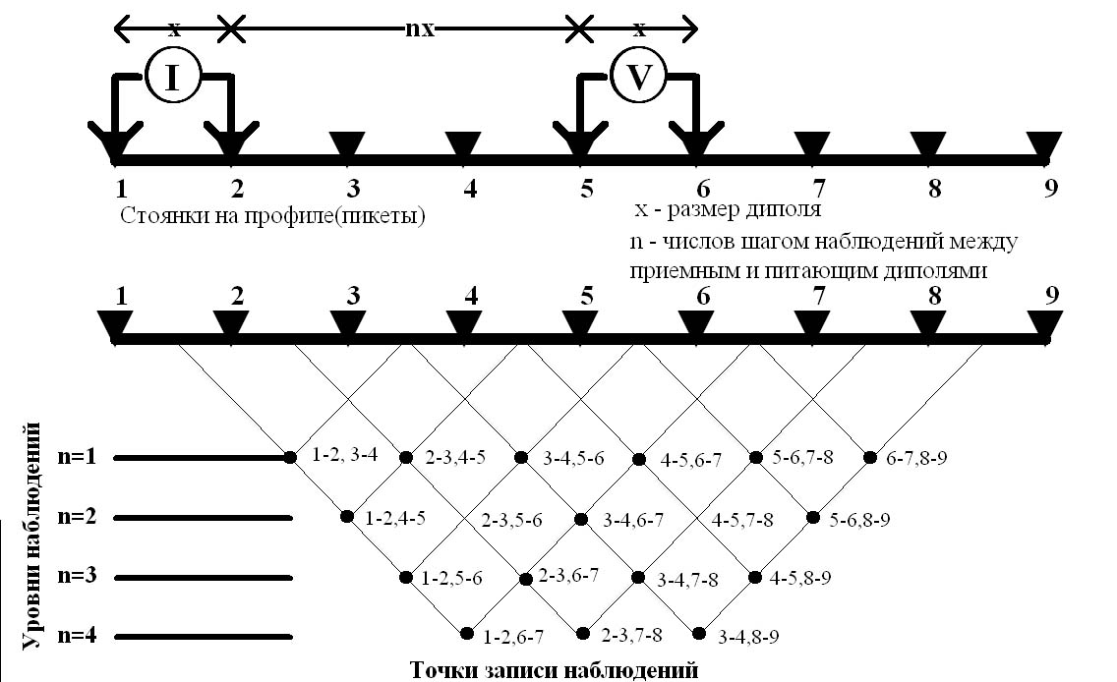
Fig. 4.4. Dipole-dipole IP scheme.

Measured data are directly filed to computer and analyzed by original software, even with geological sections compilation using MapInfo package.
For 3-D resistivity and polarization coordinates determination, original program is used with topographic data. This program allows to define precise measurement points (records) coordinates in high relief conditions.
Sectional data receiving technical feature is observation profile length from both sides must be longer than section length to the depth.
Previously, field survey results using original programs and MapInfo forwarded pseudo-geoelectric sections compiling showing general picture of geoelectrical fields distribution in vertical plane. However, these sections give anomaly-forming spatial distribution picture.
In order to draft inversion geoelectrical models, which are final variants, we use program “Rapid 2-D inversion of resistivity and IP methods data using least square method” RES2DINV (M. Loke), created by GEOTOMO SOFTWARE (www.geoelectrical.com).
RES2DINV is a computer program, automatically defining environmental resistance 2-D model for data received using topographical methods.
2-D model, used by inversion program, is composed by orthogonal blocks range, as shown at fig. 4.5.

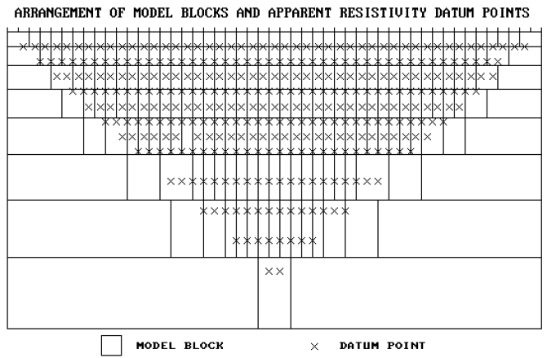

Fig. 4.5. Placement of blocks used in the model with recorded points at pseudo section.
Blocks placement is loosely connected with points distribution at pseudo section. Blocks sizes and distribution are automatically generated by the program, so blocks amount often do not exceed measuring points number. However, this program has an option for the model creation with blocks exceeding measuring points. Blocks bottom depth is equal to survey depth (Edwards, 1977) for points with maximal diversion. The survey is often performed with observation system, in which electrodes are located along the line with stable distance between electrodes. However, the program can work with data for uneven distance between electrodes. Program working purpose is to determine orthogonal blocks resistance making pseudo section of apparent resistances, coinciding with practical measuring. The first blocks range thickness is 0.5 electrode diversion for Venner’s and Shlumberge stations.
The thickness is 0.9, 0.3 and 0.6 relative electrode diversions for potential, dipole axial and three-electrode stations. Every deeper layer thickness usually increases at 10% (or 25%). Layers depths also can be manually modified by a user. Optimization method as usual tries to lessen apparent resistance diversion, counted and measured using vodel blocks resistivities variations. This diversion measure is average square error (RMS). However, a model with lowest possible RMS sometimes can derive high and unreal model resistance changes, and sometimes can considered as not the best geological model.
Generally, the most reliable method is model choice for the iteration, after which RMS do not changes significantly. Usually, it occurs between the third and the fifth iterations.
This program choice is explained by previously used interpretation methodology based on pseudo geoelectric sections interpretation, which often gives incorrect information on sectional structure. It is especially notable with subvertical bodies occurrences.
For instance, pseudo geoelectric and inversion sections are shown by polarization (Fig.4.6) and resistance (Fig.4.7) for the Kyrgyzstan one of gold-copper deposits.
It should be mentioned that polarization inversion geoelectrical section at Fig. 4.6 qietly differs from pseudo-section. At pseudo-section, anticiline anomalous structure is shown in the polarization field. It is necessary to drill its wings to check it. At inversion model, dished object with clear base is projected. Drilling totally confirmed polarization inversion model down to its base.
During field survey repeated measures with modified current can be made.
Measurement accuracy for repeated and control observations is estimated by relative error formula (%):
$$δ=\frac{1}{n}\left(\sum{\frac{X_{\text{pr}}−X_{\text{con}}}{2}×X_{S}}\right)×\text{100}$$
And average square error formula (% and Omm):
$$σ=±\sqrt{\frac{\sum{(X_{\text{pr}}−X_{\text{con}})^{2}}}{2n}}$$
where: X_{pr} – measured values,
X_{con} – control measurements,
X_{s} – measured values arithmetical mean;
n – measurements number.
Repeated observations are made from one current dipole station at all the observation levels, and in doubt cases, when it is necessary to control observation results.
Control observation volume will be not less than 5% of total volume.
IP dipole-dipole results will be shown in the form of geoelectrical inversion sections at different depths in electronic and paper variants.

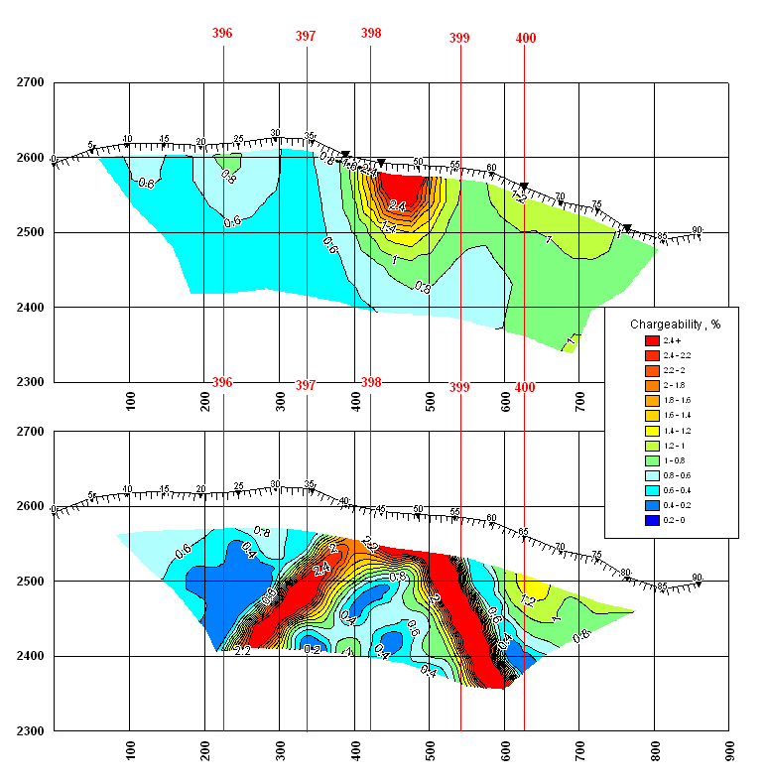
Figure 4.6. Inversion (upper) polarization pseudo-geological section.

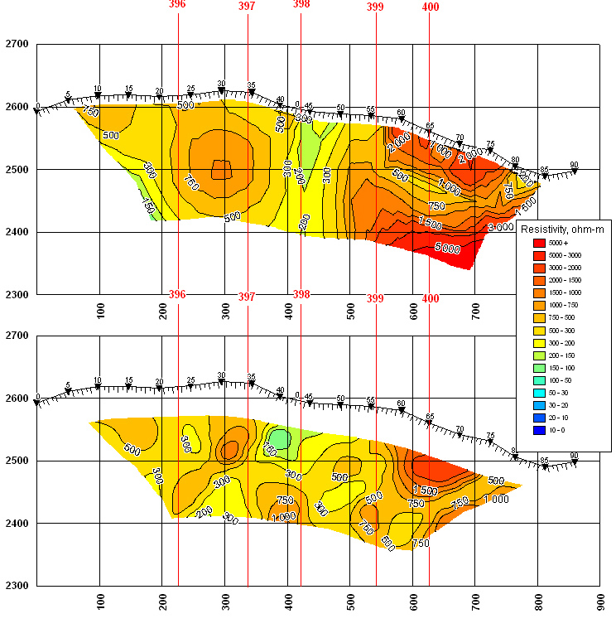
Figure 4.7. Resistivity inversion (upper) and pseudo-geological sections.

Mise-a-la-masse method
Mise-a-la masse method in potential modification is projected at Kutessay II in order to trace Northern and Central ore bodies to the depth. Working methodology is as follows: ore body uncovered with adit #28 (2293 Horizon) is grounded with current electrode (group of electrodes), the second electrode is moved to the distance more than 5-10h from the first one, i.e. it’s infinity of the first electrode. Source of power is connected to current electrodes. AB grounding line is represented by steel electrodes 15 mm in diameter and 70 cm long, grouped by 5 units at each grounding station. MN receiving line is represented by special VIRG nonpolarizing electrodes. GPSMPO cable is used for current and receiving lines installation. Receiving line current generation is made by original generator. Observation grid is 25x12.5 m.
For mise-a-la-masse method the same equipment is applied as for IP method. Zarjad.exe original program is used for mise-a-la-masse method interpretation. Normal and abnormal fields, and conducting bodies 3-D models are counted using this program.
Measured data are directly filed to computer and analyzed by original software, even with geological sections compilation using MapInfo package.

Physical properties determination
In order to study rock and ores physical properties, not less than 25 samples from every lithological type are planned. Magnetic receptivity determination using susceptimeter KT-6, produced in Czech Republic, and polarization determination using polarizometer and original equipment are planned. All the determinations will be held in laboratory conditions, at Tien Shan Ltd. base.

Topographic and geodesic support
Topographic and geodesic works are projected for:
- Geophysical observation points project transferring onto the model;
- Geophysical observation points altitudes and plan coordinates determination;
- Geophysical observation points coordinating plans compilation, 1:10000 and 1:2000 scales.
Topographic and geodesic surveys were in compliance with “Instruction for exploration’s topographic and geodesic support” published in 1984.
Field topographic and geodesic works will be held by high-precision electronic navigator. Coordinates system is Pulkovo, 1942, 13th zone.
Measured data are directly filed to computer and analyzed by original software, even with points coordinating plan compilation using MapInfo package.

Projected works volumes
As it was mentioned, works at all the known deposits and prospect evaluation zones are planned for the first order exploration. For the second order, works will be done at sparse grid prospect zones with grid thickening within most perspective zones.
Kutessay II, Kutessay III and Anjilga first order works will include 2 profile investigations using magnetic exploration, gamma-spectrometry and dipole-dipole IP. Magnetic exploration and gamma-spectrometry distance is 25 m, dipole-dipole IP – 50 m (depth – 400 m). Works volume is 3 linear km.
Mise-a-la-masse works will be performed at Kutessay II. Grid is 12.5x12.5 m, 2 charges (Northern and Central ore bodies).
Kuperlisai and Anjilga will be investigated by magnetic exploration and gamma-spectrometry using outcropping tests pits and holes with 50x25 m grid and up to 30% of overall area thickening to 25x12.5 m. Dipole-dipole IP will be held by profiles after 100 m with 50 m distance along profile.
Prospect evaluation total area is 2.2 km². Works volumes are magnetic exploration and gamma-spectrometry with 50x25 m grid – 44 km, thickening to 25x25km – 13.2 km.
Dipole-dipole IP with 100x25 m grid – 22 km.
In table 4.1 there are volumes with break into the first and the second ordered. Details at new perspective zones is 1km² area.
Table 4.1. Geophysical volumes
# | Method | Unit | Distance, m | Volume
 | First order
1 | Magnetic exploration | Linear km | 25 и 12.5 | 60.2
2 | Gamma-spectrometry | Linear km | 25 и 12.5 | 60.2
3 | IP, dipole-dipole (sounding, 15 layers, depth – 400 m) | Linear km | 50 | 22.0
4 | Mise-a-la masse method | Linear km | 12.5 | 40.0
5 | DD-IP Topographic supply | Linear km | 50 | 22.0
6 | Magnetic exploration, gamma-spectrometry and geochemistry topographic supply | Linear km | 25 и 12.5 | 60.2
7 | Mise-a-la-masse method topographic supply | Linear km | 12.5 | 40.0
 | Second order
 | Southern zone – 3.0 km²
1 | IP, dipole-dipole (sounding, 15 layers, depth – 400 m) | Linear km | 50 | 15.8
2 | Magnetic exploration | Linear km | 25 | 30.0
3 | Gamma-spectrometry | Linear km | 25 | 30.0
4 | DD-IP Topographic supply | Linear km | 50 | 15.8
5 | Surface geophysical works topographic supply | Linear km | 25 | 30.0
 | Central zone – 12.7 km²
1 | IP, dipole-dipole (sounding, 15 layers, depth – 400 m) | Linear km | 50 | 97.57
2 | Magnetic exploration | Linear km | 25 | 127.0
3 | Gamma-spectrometry | Linear km | 25 | 127.0
4 | DD-IP Topographic supply | Linear km | 50 | 97.57
5 | Surface geophysical works topographic supply | Linear km | 25 | 127.0
 | New perspective zones
1 | Magnetic exploration | Linear km | 25 и 12.5 | 26.0
2 | Gamma-spectrometry | Linear km | 25 и 12.5 | 26.0
3 | Surface geophysical works topographic supply | Linear km | 25 и 12.5 | 26.0
 | Sampling | Sample |  | 1,500.0
 | Ores and rocks physical properties definition | sample |  | 1,500.0
 | Susceptimetry in root bedding | measurement |  | 5,000.0
 | Organization and clean-up (field works 15%) | Org, clean-up |  | 1
 | Report compilation (field works 15%) | report |  | 1

